5/26/2026
Shekhar Podutwar
26/5/2026
AWS CI/CD Automation Using Webhook and Poll SCM in Jenkins
Configuring Webhook and Poll SCM jobs

Contents

Document Version History……………………………….…………………………………………….1
Introduction…………………….…………………………………………………………………………….2
Objectives…………………….………………………..….………………………………………………….3
Tools & Technologies Used…………………………………………………………………………….4
Architecture Overview ………………………………………………………………………………….5
Step-by-Step Implementation …………………………………..………………………………….6
Conclusion…………………………………………………………………………………………………….7

Document Version History

Version Number | Date Modified | Author | Changes
Draft | 22/5/2026 | Shekhar | Draft Version

Introduction
This project focuses on implementing Continuous Integration automation by configuring Webhook and Poll SCM jobs in Jenkins hosted on Amazon Web Services infrastructure. The objective was to automate the build process whenever developers pushed code changes to the source code repository.
Webhook integration enabled instant build triggering based on repository events, while Poll SCM was configured to periodically check for code changes in the repository. This project improved build automation, reduced manual intervention, and enabled faster and more reliable CI/CD workflows.

Objectives

- Automate build triggering using Webhook integration.
- Configure Poll SCM jobs for periodic source code monitoring.
- Implement Continuous Integration workflow using Jenkins.
- Reduce manual build and deployment activities.
- Improve development efficiency and faster code validation.
- Gain hands-on experience in CI/CD pipeline automation.
Tools and Technologies
Category | Tools / Technologies
Cloud Platform | Amazon Web Services (AWS)
Automation Tool | Jenkins
Version Control | GitHub
Compute Service | Amazon EC2
Operating System | Linux (Ubuntu / Amazon Linux)
Build Trigger Method | Webhook, Poll SCM
Networking | Security Groups, SSH
CI/CD Concepts | Continuous Integration, Automated Build Triggering

Architecture Overview
Developer Code Commit
↓
GitHub Repository
↓
Webhook Trigger / Poll SCM Monitoring
↓
Jenkins Server on AWS EC2
↓
Automated Build Execution
↓
Build Validation & Deployment Process
↓
Application/Server Update

Step-by-Step Implementation
Step 1: Login AWS and create an instance
- Select AMI (Ubuntu Server 24.04 LTS (HVM), SSD Volume Type)
- Create a Jenkins key pair
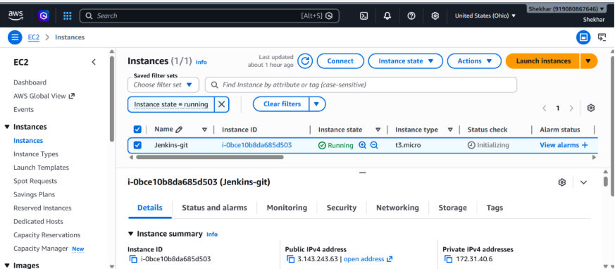
Step 2: Connect putty and run following commands
- ubuntu
- Sudo su -
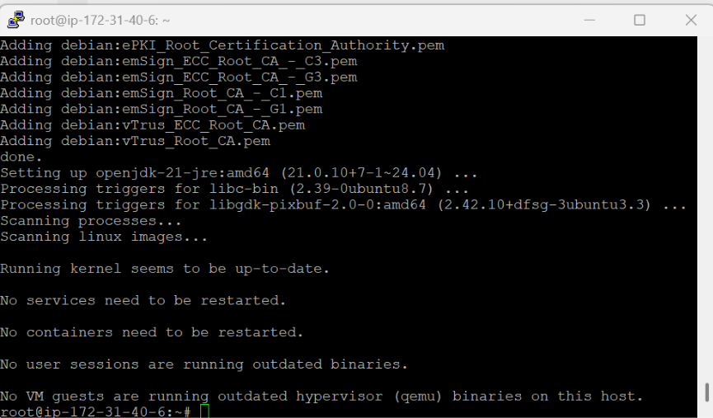

- Update the repository.
(apt update –y)

- Install the Java package.
(apt install fontconfig openjdk-21-jre –y)

- Download the official Jenkins GPG key.
wget -O /etc/apt/keyrings/jenkins-keyring.asc
https://pkg.jenkins.io/debian-stable/jenkins.io-2026.key

- Add the Jenkins repository to the system.
echo "deb [signed-by=/etc/apt/keyrings/jenkins-keyring.asc]" https://pkg.jenkins.io/debian-stable binary/ | sudo tee
/etc/apt/sources.list.d/jenkins.list > /dev/null

- Update the repository again.
(apt update –y)

- Install Jenkins.
(apt install jenkins –y)

- Start the Jenkins service.
(systemctl start jenkins)

- Add the Jenkins user to the sudoers file.
vim /etc/sudoers
jenkins ALL=(ALL) NOPASSWD: ALL

Step 3: Open port no 8080
- Security --> security group --> edit inbound rule --> add rule
- Must be select Any-where-Ipv4
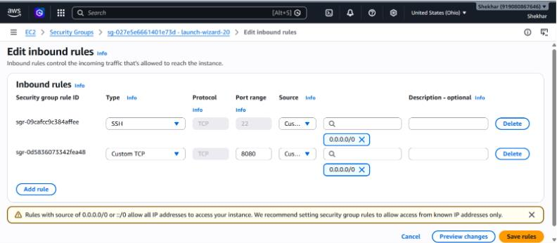
Step 4: To configure Jenkins
- Connect to http:public_ip:8080 from our browser.
- We will be able to access Jenkins through its management interface:
- Default home directory for Jenkins
  - (/var/lib/jenkins)
- workspace directory of Jenkins. (/var/lib/jenkins/workspace/job1/file1)
- For password
  - (cat past path)
  - (cat /var/lib/jenkins/secrets/initialAdminPassword)
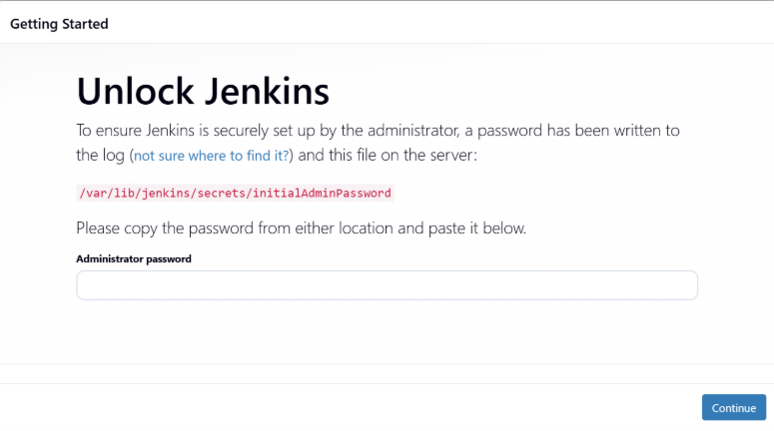

Step 5: Now you can access Jenkins dashboard
- Select installs suggested plugins
- Then set up username and password

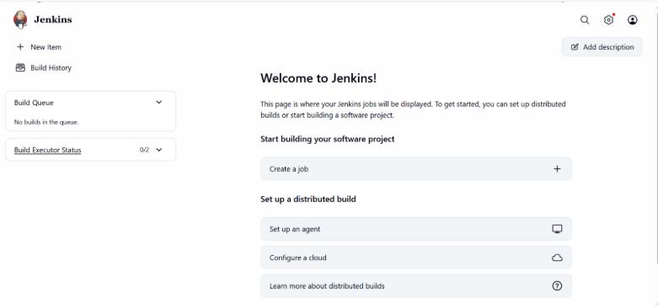

Step 6: Setup Webhooks
- Go to remote repository
- Repository--> setting--> webhook--> add webhook--> payload URL(Jenkins url)--> add webhook

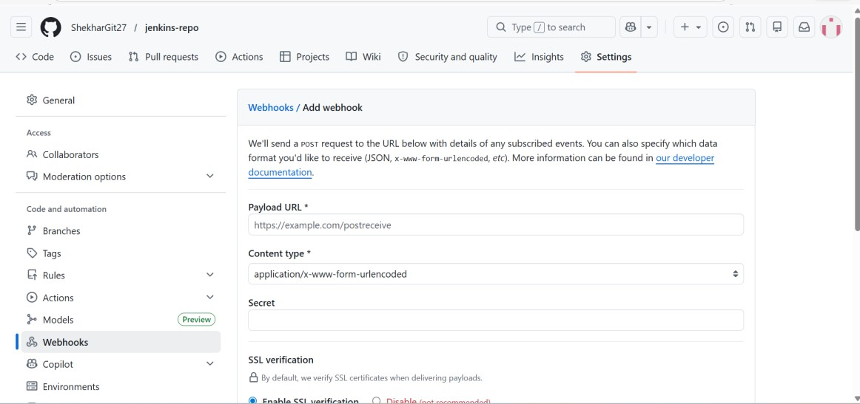

Step 7: Create a job in Jenkins (for webhook)
- Now you can create job in Jenkins
- New item--> job--> freestyle project
- Go to source code management select git
- And add Git URL
- Go to triggers section
- Select GitHub hook trigger for GITScm polling
- Apply and save
- Build job

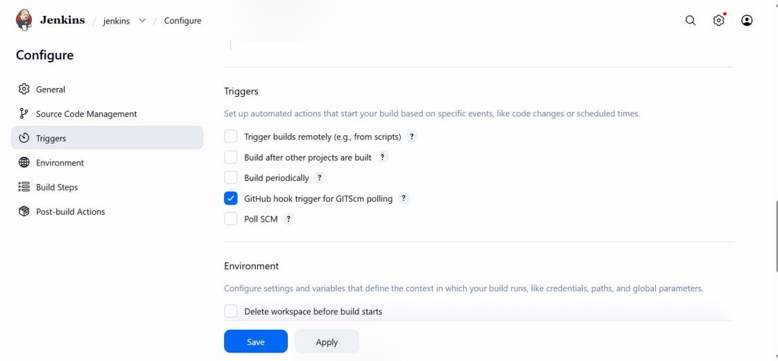

Step 8: Setup Poll SCM
- Go to source code management select Poll SCM
- Add trigger time
- Ex. (Min hr date month day)
- Run job every 5 min
- (*/5 * * * *)
- Apply and save
- Build job

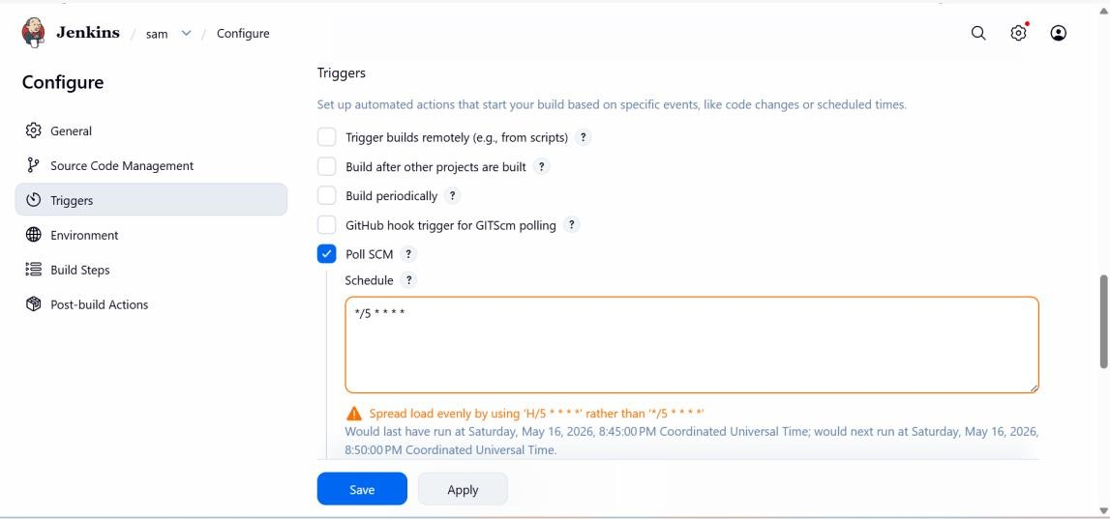

Step 9: default Jenkins directory
- Now you can create job in Jenkins
- Default home directory for Jenkins
  - (/var/lib/jenkins)
- workspace directory of Jenkins.
  - (/var/lib/jenkins/workspace/jenkins/project name)
- Here you can check your changes

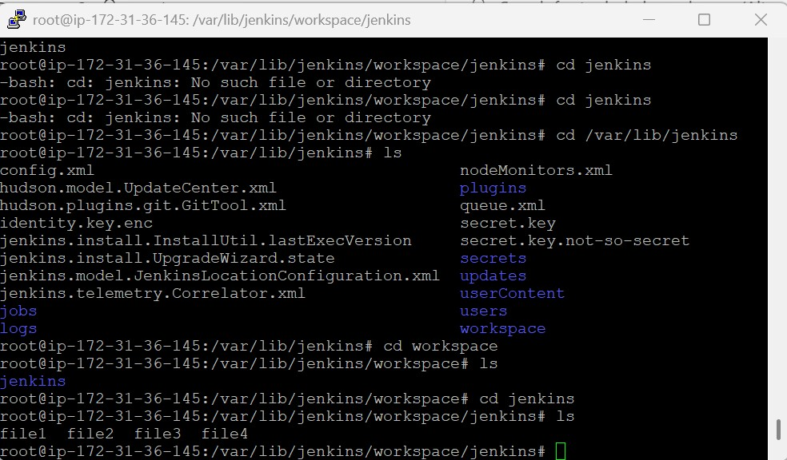

Conclusion
This project successfully implemented CI automation using Webhook and Poll SCM integration with Jenkins on Amazon Web Services infrastructure. The automation process enabled real-time and scheduled build triggering, reducing manual efforts and improving software delivery efficiency. The project provided hands-on experience in Jenkins job configuration, GitHub integration, CI/CD pipeline automation, and cloud-based DevOps practices, helping create a more reliable and efficient development workflow.

